Report lab 8
CustomerRestController.java
This class CustomerRestController is a Spring Boot REST controller that handles customer-related API requests.
It maps all endpoints under /api/customers and allows cross-origin requests for frontend access.
It provides CRUD operations: get all customers, get by ID, create, update, and delete customers using CustomerService.
It also supports searching customers by keyword and filtering them by status.
Responses are wrapped in ResponseEntity to return proper HTTP status codes and JSON data.
CustomerRequestDTO.java
This DTO represents the data structure for customer requests in the API.
It uses Jakarta Validation annotations to enforce rules like required fields, size limits, and regex patterns.
CustomerCode must start with "C" followed by digits, while fullName, email, and phone have strict validation formats.
Optional fields like address and status allow extra customer details with constraints (e.g., max 500 chars for address).
The class includes constructors plus standard getters and setters for all fields to support object creation and manipulation.
CustomerReponseDTO.java
This DTO is used to send customer data back to the client in API responses.
It contains fields like id, customerCode, fullName, email, phone, address, status, and createdAt.
Unlike the request DTO, this class doesn’t enforce validation rules—it’s purely for output.
It provides constructors for easy object creation and standard getters/setters for field access.
The createdAt field uses LocalDateTime to capture when the customer record was created.
ErrorReponseDTO.java
This DTO represents the structure of error responses returned by the API.
It includes fields like timestamp, status, error, message, path, and optional details for extra info.
The timestamp is automatically set to the current time when an error response is created.
Constructors allow quick initialization with key error information, while getters/setters provide access and modification.
It helps standardize error handling so clients receive consistent, informative JSON error messages.
Customer.java
This class maps to the customers table in the database using JPA annotations.
It defines fields like id, customerCode, fullName, email, phone, address, status, createdAt, and updatedAt.
Constraints such as unique, nullable, and length ensure proper validation at the database level.
Lifecycle hooks @PrePersist and @PreUpdate automatically set timestamps when records are created or updated.
It includes constructors plus getters and setters for all fields, enabling easy persistence and retrieval of customer data.
Duplicate Resource Exception.java
DuplicateResourceException is a custom exception class in Java.
It extends RuntimeException, making it an unchecked exception.
Used when a duplicate resource (like email, username, or record) is found.
Provides constructors for message-only or message with cause.
Often mapped to HTTP 409 Conflict in REST APIs for clarity.
GlobalExceptionHandler.java
•Handles ResourceNotFoundException (404)
Returns a Not Found response when a resource doesn’t exist.
Example: customer ID not found.
Handles DuplicateResourceException (409)
Returns a Conflict response when a duplicate resource is detected.
Example: trying to register an email that already exists.
Handles MethodArgumentNotValidException (400)
Collects validation errors from request body fields.
Returns a Validation Failed response with detailed field error messages.
Handles all other exceptions (500)
Catches unexpected errors.
Returns an Internal Server Error response with the exception message.
Run-demo
1. [
{
"id": 1,
"customerCode": "C001",
"fullName": "John Doe",
"email": "john.doe@example.com",
"phone": "+1-555-0101",
"address": "123 Main St, New York",
"status": "ACTIVE",
"createdAt": "2025-12-04T15:58:14"
},
{
"id": 2,
"customerCode": "C002",
"fullName": "Jane Smith",
"email": "jane.smith@example.com",
"phone": "+1-555-0102",
"address": "456 Oak Ave, Los Angeles",
"status": "ACTIVE",
"createdAt": "2025-12-04T15:58:14"
},
{
"id": 3,
"customerCode": "C003",
"fullName": "Bob Johnson",
"email": "bob.johnson@example.com",
"phone": "+1-555-0103",
"address": "789 Pine Rd, Chicago",
"status": "ACTIVE",
"createdAt": "2025-12-04T15:58:14"
}
]
2.
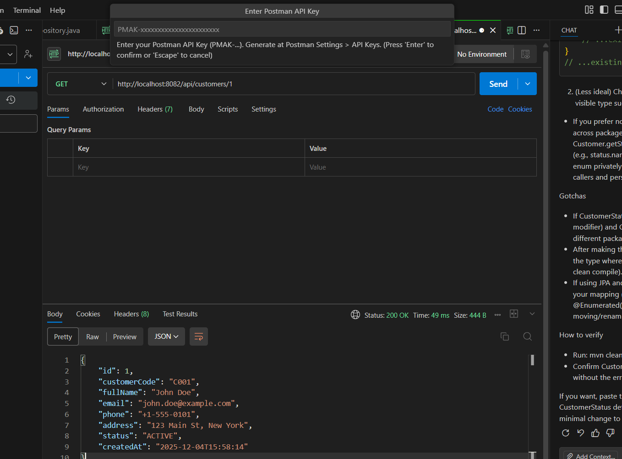
3.
[
{
"id": 1,
"customerCode": "C001",
"fullName": "John Doe",
"email": "john.doe@example.com",
"phone": "+1-555-0101",
"address": "123 Main St, New York",
"status": "ACTIVE",
"createdAt": "2025-12-04T15:58:14"
},
{
"id": 2,
"customerCode": "C002",
"fullName": "Jane Smith",
"email": "jane.smith@example.com",
"phone": "+1-555-0102",
"address": "456 Oak Ave, Los Angeles",
"status": "ACTIVE",
"createdAt": "2025-12-04T15:58:14"
},
{
"id": 3,
"customerCode": "C003",
"fullName": "Bob Johnson",
"email": "bob.johnson@example.com",
"phone": "+1-555-0103",
"address": "789 Pine Rd, Chicago",
"status": "ACTIVE",
"createdAt": "2025-12-04T15:58:14"
}
]
4.

